Programming Concepts
Week 2 Pass Submission Tasks Template

Student ID: _____103055993________________
Student Name: ________Mario Stavreski______________________

Pass Task 5 set of screenshots – first test

Paste the screen captures of the resulting web page as shown by the browser here.
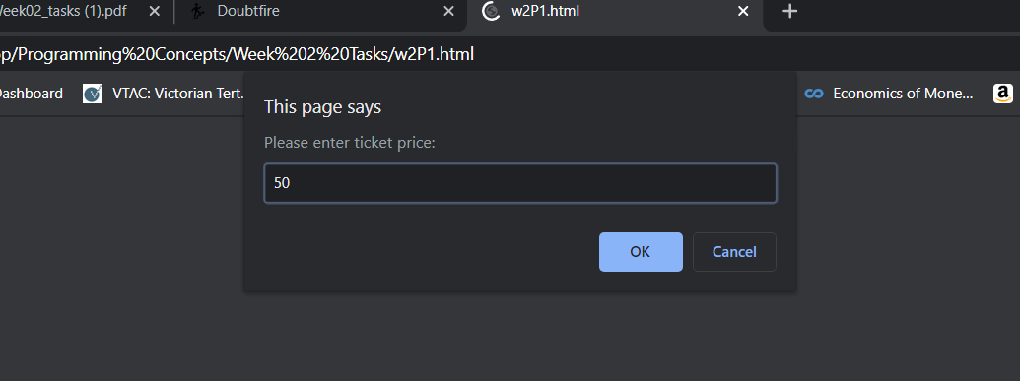
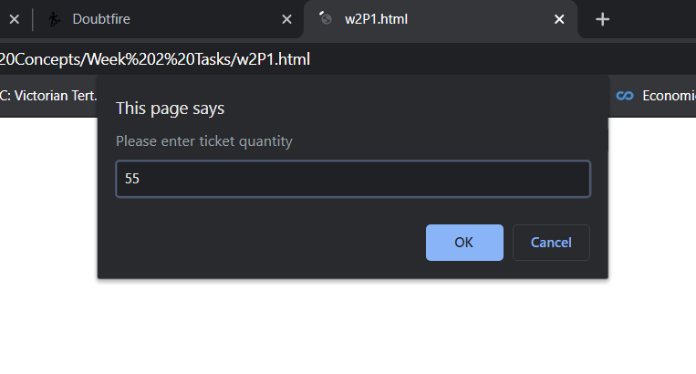
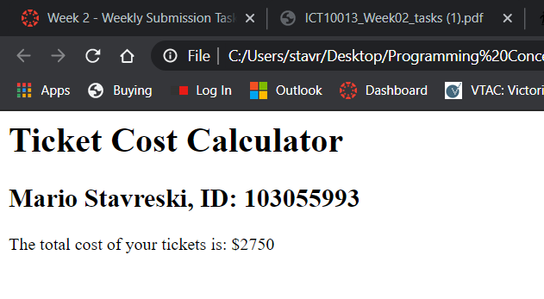

Pass Task 5 set of screenshots – second test

Paste the screen captures of the resulting web page as shown by the browser here.
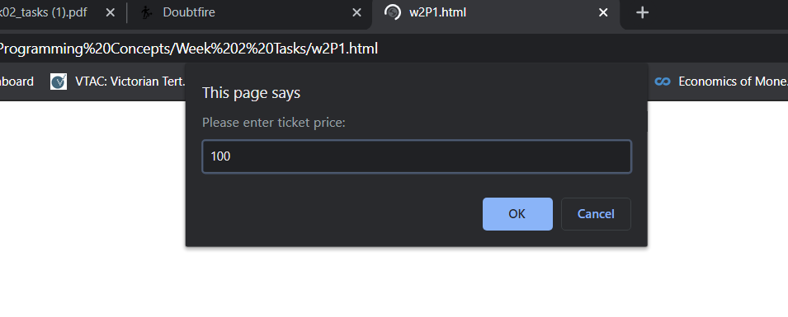
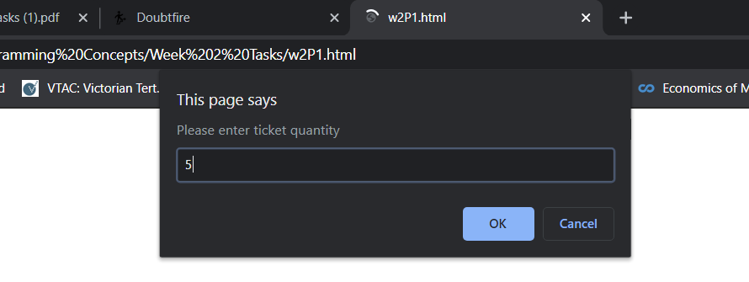
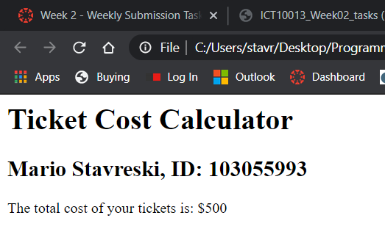

Pass Task 5 html code

Paste the html code of the same page here.
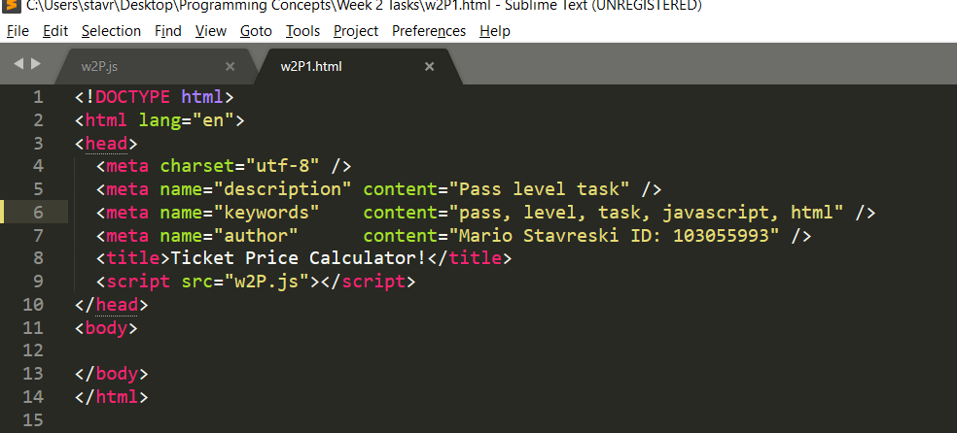

Pass Task 5 JavaScript code

Paste the JavaScript code of the same page here.

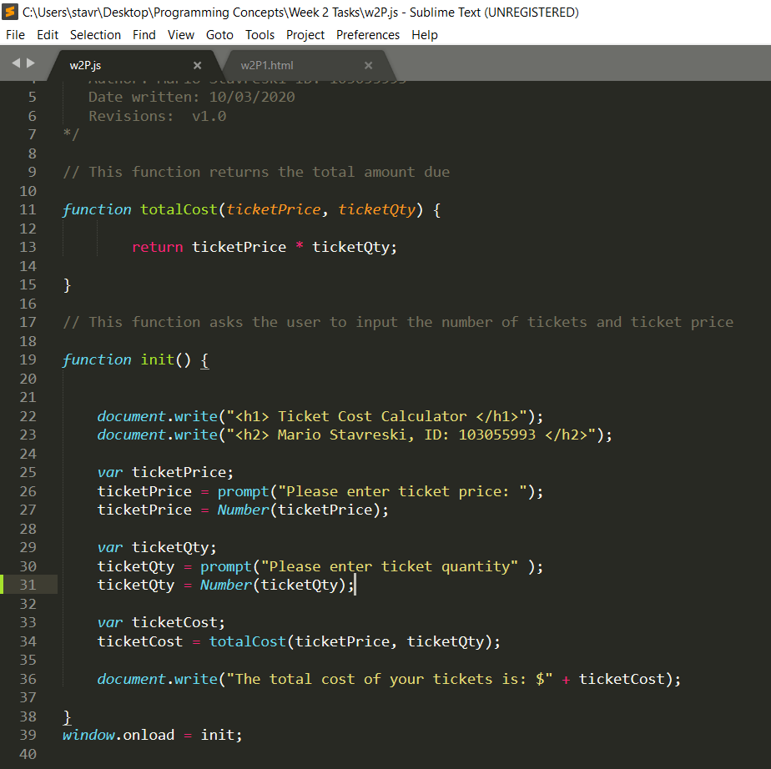Pass Task 12

Paste the screen capture of the potter.html web page here.
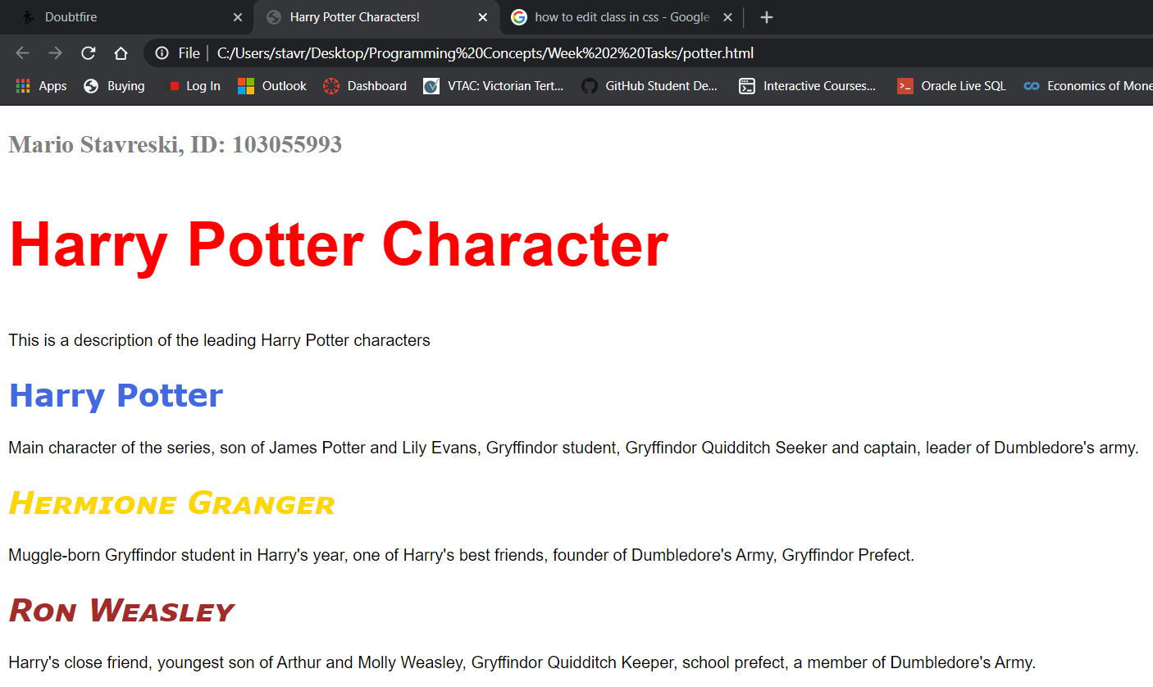

Pass Task 12 html code

Paste the html code of the same page here.
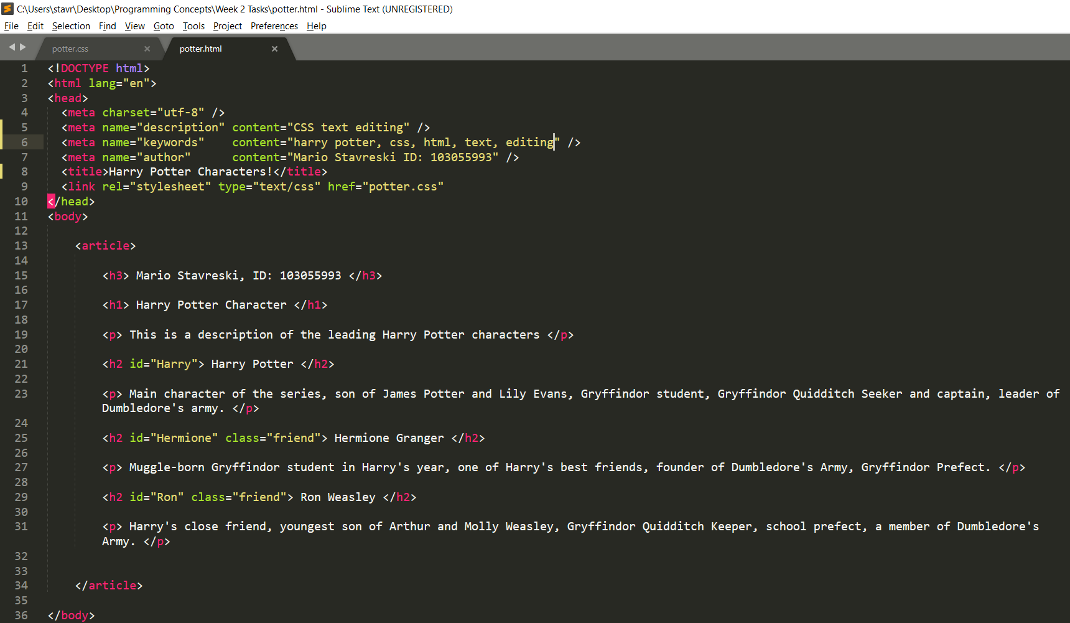

Pass Task 12 CSS code

Paste the CSS code of the same page here.
